

2026 Summer Schedule

IMPORTANT PAYMENT DUE DATES
- May 1st
  - Optional May & June Technique Classes
- June 1st
  - Required Technique/Rehearsal Classes
  - Optional July Technique Classes
  - Skills & Drills Camp Fees
  - Recreational & Intermediate Camps Fees
  - Boot Camp Deposit $250
- July 1st
  - Boot Camp - Remaining Balance
  - Optional August Technique Classes
  - Ballet Intensive Fees
- August 1st
  - 26/27 Company Fees

REQUIRED Summer Classes/Rehearsals
*See full summer class/rehearsal schedule* (will be published on band and in email)

June 9th, 23rd & August 18th Required Technique Classes
*Mandatory for all current 25/26 & and upcoming 26/27 competitive & performance company members
June 9th, 23rd, 29th, July 10th Required Rehearsals
*Mandatory for all 25/26 competitive company members

Required Summer Classes/Rehearsals Pricing:
*Please note: Camps & Optional Prices Not Included
Performance Company & New to Company Members - $200
Levels 2 - 6 - $250

Company Rehearsal/Nationals Send Off Party – July 10th
*Clean Advantage Warehouse (Taylors)
*Required for ALL current company members attending Nationals
- 9:30am-10:00am – Warm-up
- 10:00am-11:15am – Run All Routines
- 11:15am-12:00pm – Nationals Send-off Party

REQUIRED CAMPS & INTENSIVES

Skills & Drills Summer Camp – June 10-11
*Mandatory for ALL age 8 and under (as of July 1st 2026) Performance & Competitive Company
members
- Ages 8 & under - 10:00am-2:30pm
Registration Deadline: June 1st - $150

Beginner & Intermediate Summer Camps - June 22-25
*Mandatory for all age 9 and above 26/27 performance company members and optional for
competitive company members*
- 9:00am-11:00am – Royal Dance Adventure Prince & Princess Camp (Ages 3-5)
Registration Deadline: June 1st - $160 before deadline, $180 after deadline
- 9:00am-12:15pm – Glitz & Glam Camp (Ages 6-9)
Registration Deadline: June 1st - $235 before deadline, $270 after
- 1:00pm-4:15pm – Unstoppable Dance Camp (Ages 10+)
Registration Deadline: June 1st - $235 before deadline, $270 after
Summer Intensive/Bootcamp – July 7-9
*Mandatory for ALL 25-26 & New 26/27 Competitive Company members 9+ as of July 1st 2026
(optional but encouraged for Performance Company members)
*Ages 8 and under by staff recommendation only
*$250 due on June 1st - balance due July 1st
- Age (9-10) - 9:00-2:00pm - Cost $400
- Age (11-14) - 9:00-3:30pm - Cost $550
- Age (15+) - 10:30-5:00pm - Cost $550

Ballet Summer Intensive – July 22- 24
*Required for ALL 2026/2027 company members & Performance company members
**Dancers will be registered by the studio in the appropriate level

Level 1 - 9:00am-10:00am - $100
- Level 2 - 10:00am-11:00am - $100

Level 3 - 11:00am-12:15pm - $115

Level 4 - 12:30pm-1:45pm - $115

Level 5 - 1:45pm-3:45pm - $165

Level 6 - 4:00pm-6:00pm - $165

OPTIONAL SUMMER CLASSES

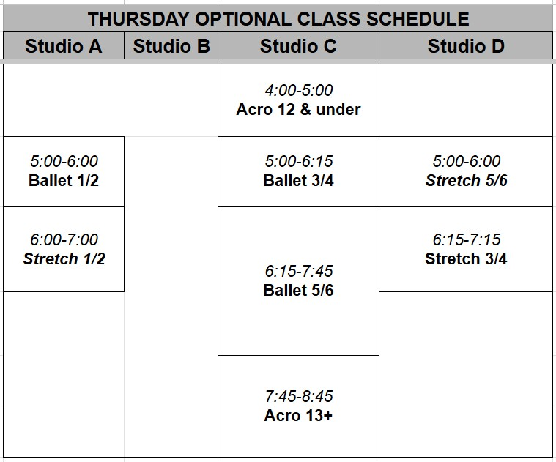
NEW THIS SEASON! Weekly Tuesday & Thursday optional training opportunities!
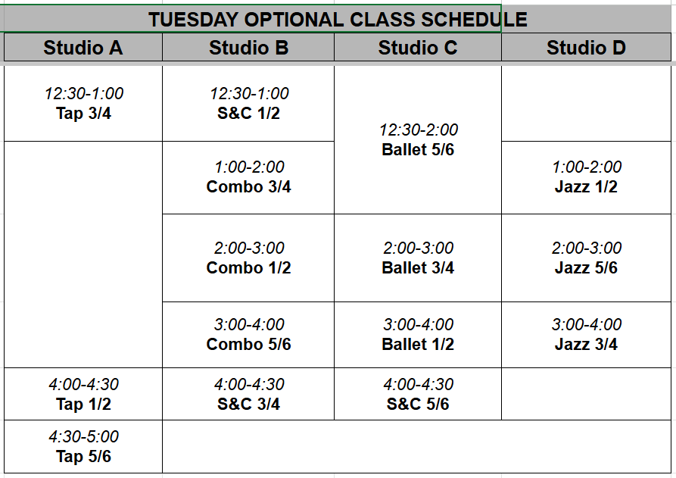
Tuesday Optional Dates Thursday Optional Dates
May 26 May 28
June 16, 30 June 4, 11, 18, 25
July 21, 28 July 2, 30
August 4,11, 25 August 6, 13, 27
Tuesday Pricing Thursday Pricing
Level (1-4) Level (1-4) Ballet & Stretch
Package of any 4 days - $250 Package of any 4 days - $120
Drop in day rate - $70 Drop in day rate $35
Level (5-6) Level (5-6) Ballet & Stretch
Package of any 4 days - $275 Package of any 4 days - $150
Drop in day rate - $75 Drop in date rate -$45
Single Class Rates (Tuesday & Thursdays) Acro
.5 hour - $20 Package price of any 4 days - $80
1 hour - $25 Single acro class - $25
1.5 hour - $30

OTHER IMPORTANT DATES

Starpower Nationals - July 12th-16th (Myrtle Beach, SC)
*Required for ALL 2025-2026 Company Members

SHOCK RECREATIONAL OPEN HOUSE August 20th (4:00pm-7:00pm)
**NOT required for 26/27 Company Members**
**Please note: The mandatory parent meeting will now be held on August 22nd after the FAM Parent Workshop

FAM Company Culture & Mentor Pairing Event Required- August 22nd - $90
- Lisette Bustamente Culture Event - 10:00am-3:00pm
*This is a required event for all age 9 and above - 26/27 Performance & Competitive Company members
- Parent Workshop - 3:00pm-4:00pm
*Hosted by Lisette Bustamente, required for all Shock Performance & Company Parents
*Company Parent meeting will happen at the end of this talk - required for parents
- FAM Reveal - 3:00pm-4:00pm
*Meet your mentor/mentee - celebrate the season ahead!
- Meet & Greet/Measurements - 4:00-5:00pm
*Meet new Shock families, catch up with old friends, costume measurements, finalize registration & Shock merchandise.

Tuesday, September 1st - Fall Classes Begin!

GENERAL INFORMATION
- $20 per half hour, $25 per hour, $30 per hour and a half for individual summer technique classes
(for optional technique classes or non-company members)
- $70 day pass for optional Technique Tuesdays Level 1-4, $75 for Level 5-6
- $35 for optional Technique Thursdays Level 1-4, $45 for Level 5-6
- Private lessons available in all genres (email: Shockdancebylindley@gmail.com)
- Refer a friend who signs up for the fall semester and receive a $50 credit
  - Email portal@shockdancebylindley.com after your referral enrolls to receive your credit

SUMMER CALENDAR RECAP
May
- May 26th Optional Tuesday Classes
- May 28th Optional Thursday Classes

June
- June 2nd - Recital - Required for All 25/26 Company Members
- June 4th - Optional Thursday Classes
- June 9th - Required Technique & Rehearsals
- June 10th-11th - Skills & Drills Required for age 8 and under
- June 11th - Optional Thursday Classes
- June 16th - Optional Tuesday Classes
- June 18th - Optional Thursday Classes
- June 22nd-25th - Beginner/Inter Summer Camps Required for Performance Company
- June 23rd Required Technique & Rehearsals
- June 25th - Optional Thursday Classes
- June 29th - Required Rehearsal (for 25/26 Company Members)
- June 30th Optional Tuesday Classes

July
- July 2nd - Optional Thursday Classes
- July 7th - 9th - Bootcamp (Required) for all 9+ competitive members optional for performance
- July 10th - Rehearsal/National Send Off Party (Required for 25/26 Company Members)
- July 11th-16th - StarPower Nationals Myrtle Beach (Required for 25/26 Company Members)
- July 21st - Optional Tuesday Classes
- July 22nd - 24th - Ballet Summer Intensive (Required for all 26/27 Company Members)
- July 28th - Optional Tuesday Classes
- July 30th - Optional Thursday Classes

August
- August 4th - Optional Tuesday Classes
- August 6th - Optional Thursday Classes
- August 11th - Optional Tuesday Classes
- August 13th - Optional Thursday Classes
- August 18th - Technique Tuesday (Required for all 26/27 Company Members)
- August 20th - Recreational Open House (NOT required for 26/27 Company)
- August 22nd - Shock Culture Event/FAM Pairing/Parent Meeting (Required for dancers and parents of 26/27 Company)
- August 25th - Optional Tuesday Classes
- August 27th - Optional Thursday Classes

September
- September 1st - FALL CLASSES BEGIN!

